Ideation Phase
Brainstorm & Idea Prioritization Template
Date | 14 January 2026
Team ID | ------------------------
Project Name | ShopEZ - Full Stack E-Commerce Platform
Maximum Marks | 4 Marks

Brainstorm & Idea Prioritization Template:
Brainstorming was used to identify the major problems, possible solution ideas, and important features for the ShopEZ MERN e-commerce project. The team focused on building a simple, secure, and user-friendly online shopping system with user and admin roles.
Step-1: Team Gathering, Collaboration and Select the Problem Statement
Problem Statement
Users need a simple online shopping platform where they can browse products, view product details, add products to cart, manage quantities, checkout with proper price calculation, and view orders. Administrators need a dashboard to manage products and orders. The proposed solution is ShopEZ, a full stack e-commerce application developed using React.js, Node.js, Express.js, and MongoDB.
Team Collaboration Summary
- Discussed customer pain points such as confusing checkout, missing order summary, and weak product management.
- Selected MERN stack because it supports full stack JavaScript development and easy API integration.
- Decided to include role-based access for users and administrators using JWT authentication.
- Prioritized core e-commerce features first, then listed optional future enhancements.
Stakeholder | Need / Problem | ShopEZ Solution
Customer / User | Needs quick product browsing and easy ordering. | React product catalog, product details, cart, checkout, and orders.
Administrator | Needs control over products and order monitoring. | Admin dashboard with product management and order viewing.
Developer / Team | Needs maintainable code and database structure. | MERN MVC structure with routes, controllers, models, and reusable UI pages.

Step-2: Brainstorm, Idea Listing and Grouping
Brainstormed Ideas
Category | Ideas Generated | Reason / Benefit
User Features | Register, login, profile page, product listing, product details, add to cart, quantity increase/decrease, remove item, checkout, order history. | Improves shopping flow and makes the system usable for customers.
Admin Features | Admin dashboard, add product, delete product, view all products, view all orders. | Gives administrator control over e-commerce data.
Security Features | JWT token authentication, bcrypt password hashing, protected routes, admin-only access. | Prevents unauthorized access and protects user accounts.
Checkout Features | Delivery details form, order summary, subtotal, GST, delivery charges, grand total, payment method. | Makes checkout professional and clear for users.
UI/UX Features | Black and blue theme, responsive cards, hover transitions, clear navigation bar, user-friendly buttons. | Improves look, navigation, and demo presentation quality.
Future Features | Payment gateway, wishlist, search/filter, product reviews, email notifications, order tracking. | Can improve the project after the first release.
Idea Grouping
Group | Features | Priority Reason
Must Have | Registration, Login, Products, Product Details, Cart, Checkout, Orders, Admin Dashboard. | Required to satisfy the main e-commerce workflow.
Should Have | GST and delivery calculation, role-based admin access, product delete, responsive UI, hover effects. | Improves quality and makes the project more realistic.
Could Have | Search/filter, wishlist, reviews, online payment, order tracking. | Useful enhancements after the basic system is complete.

Step-3: Idea Prioritization
Ideas were prioritized based on two factors: importance to the e-commerce workflow and feasibility within the project development timeline. High importance and high feasibility items were selected for the first release.
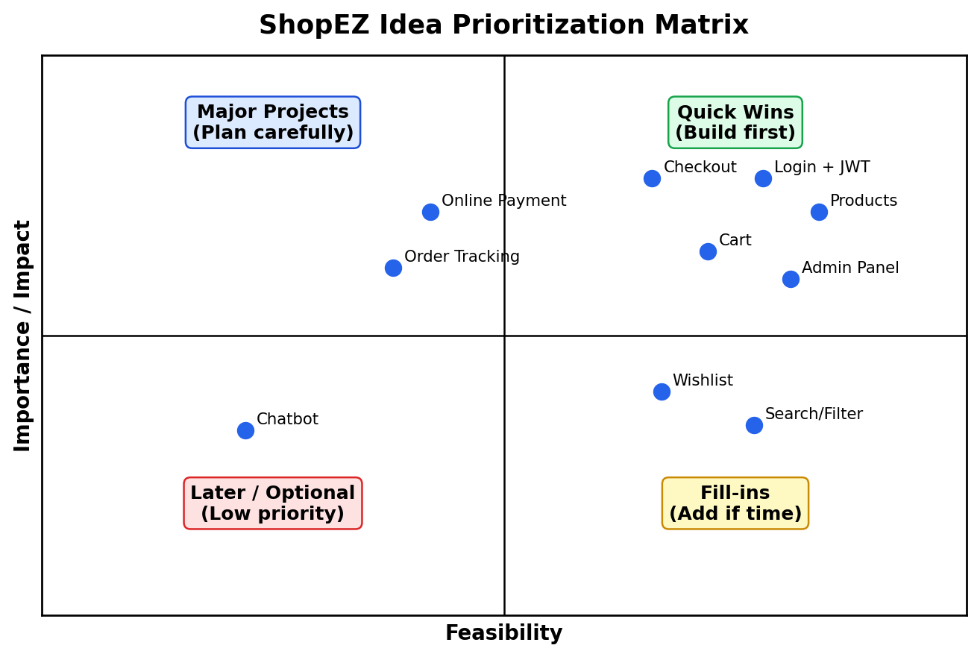

Prioritized Feature List
No. | Idea / Feature | Importance | Feasibility | Priority | Release
1 | User registration and login with JWT | High | High | High | Sprint-1
2 | Product catalog and product details page | High | High | High | Sprint-1
3 | Cart management with quantity buttons | High | High | High | Sprint-1
4 | Checkout with delivery details, GST, delivery charges and total | High | High | High | Sprint-1
5 | Admin dashboard and product management | High | Medium | High | Sprint-2
6 | Order history and order management | High | Medium | High | Sprint-2
7 | Search/filter, wishlist and reviews | Medium | Medium | Medium | Future
8 | Online payment gateway and order tracking | High | Medium | Medium | Future
9 | Chatbot / recommender | Low | Low | Low | Future
Final Selected Idea
The final selected idea is to develop ShopEZ, a MERN stack e-commerce web application with user authentication, product browsing, cart management, checkout with full price calculation, order management, and an admin dashboard. This idea was selected because it is highly relevant, feasible to implement, and demonstrates important full stack development concepts.

